**jQuery**

1. jQuery is a lightweight, "write less, do more", JavaScript library.
2. The purpose of jQuery is to make it much easier to use JavaScript
3. jQuery has plugins for almost any task out there. <https://plugins.jquery.com/>
   1. Image slider
   2. Date picker
   3. Calendar
   4. Animations
4. Include in the head section of HTML - <script src="jquery-3.3.1.min.js"></script>
5. jQuery CDN
   1. <script src="<https://ajax.googleapis.com/ajax/libs/jquery/3.3.1/jquery.min.js>"></script>
6. jQuery Syntax
   1. $(selector).action()
   2. $("p").hide() - hides all <p> elements.
   3. $(".test").hide() - hides all elements with class="test".
   4. $("#test").hide() - hides the element with id="test".
   5. 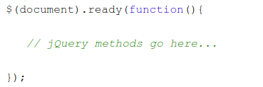
7. jQuery Selectors
   1. jQuery selectors allow you to select and manipulate HTML element(s).
   2. Element selector - $("p")
   3. Id selector - $("#test")
   4. Class selector - $(".test")
8. Events
   1. click, dblclick, mouseenter, mouseleave
   2. keypress, keydown, keyup
   3. Submit, change, focus, blur
   4. Load, resize, scroll, unload
   5. 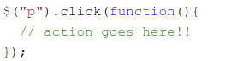
9. Callback function
   1. 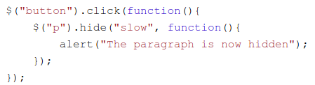
10. Chaining - $("#p1").css("color", "red").slideUp(2000).slideDown(2000);
11. content and attributes
    1. Get
       1. elemt.text()
       2. elemt.html()
       3. elmet.val()
    2. Set
       1. $("#test1").text("Hello world!");
       2. $("#test2").html("<b>Hello world!</b>");
       3. $("#test3").val("Dolly Duck");
       4. $("#w3s").attr("href", "<https://www.w3schools.com/jquery/>");
    3. Add
       1. $("p").append("Some appended text.");
       2. Prepend
       3. Before
       4. After
    4. Remove
       1. $("#div1").remove();
       2. $("#div1").empty();
    5. $("h1, h2, p").addClass("blue");
    6. $("p").css("background-color");
12. ajax() Method
    1. 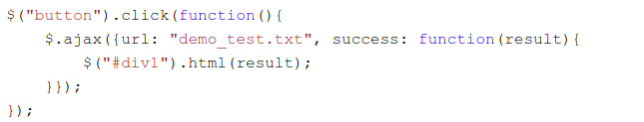

**Assignments**:

1. Create a form and add JQuery validations on submit
   1. Name(Required)
   2. email(Required, should be of type email)
   3. Mobile number(Not required, should only support indian numbers)
   4. date_of_birth(Required, should show date picker)
   5. Show age automatically when they enter date of birth
   6. Country(Dropdown, required) - Use Select2 - https://select2.org/dropdown
2. Using JQuery ajax, fetch data from API - <https://jsonplaceholder.typicode.com/posts> and show it in a listing page on page load
3. Create an HTML page like <https://www.jabong.com/Adidas-Nemeziz-17-4-Tf-White-Football-Shoes-300141923.html?pos=1&cid=AD004SH43FXHINDFAS> and implement below features:
   1. Build an HTML upto product info and similar picks
   2. Image slider should be implemented
   3. Option to add to cart and on add show a popup
   4. On hover on the cart it should show cart items
   5. Cart item should be saved to localStorage <https://www.w3schools.com/html/html5_webstorage.asp>. So that the added item should be persist in the cart hover box.
   6. Add an extra option to delete the item from the cart(delete from localStorage)
   7. On clicking on signin it should popup a login page.